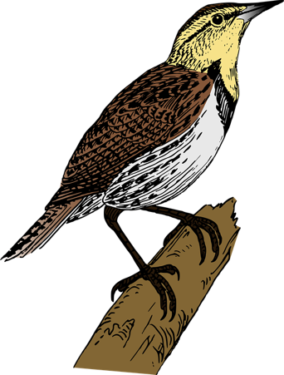
LC: Can you sing different pitch patterns and create a new musical story relating to the piece?

Should the lark fly away, descend back to earth or something else?

