Writing  Write an alternative ending to your favourite story.  Write a character description of your favourite book character.  Become an author and create your own book.  Write a book review.  Make a list of all the books you would like to read in the future.  Take the first line of your favourite book and use it to write a different story. | World Book Day Menu  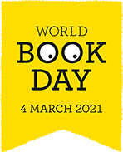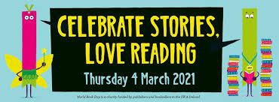 | History  Find out about the author of the book and their life – you could create a timeline for them or write a biography about them.  Find out about the history of books and the first books to be written/published in England.
Geography
Choose ten books. Using an atlas, can you locate where each one is set?
Reading  Create six comprehension questions based on a book/chapter you enjoy.  Cosy up with your favourite book and a cushion.  Record an audio book for a chapter or record a whole book if it is short.  If you were to have an adventure with a book character, who would you choose and why? | Additional Activities  Design/build a reading corner/den somewhere in your home.  Create the best ‘reading snack plate’ to enjoy whilst reading your favourite book.  Organise your book shelf at home by sorting your books A-Z.  Design the perfect day out for a book character from the moment they wake up to going to bed again at night time.  Listen to the World Book Day song, print the pack to go with it and complete the activities.  https://www.youtube.com/watch?v=ZpTkjssrL4k&feature=youtu.be&ab_channel=MCGrammar  Design a book mark so that you never lose your place!  Draw along with Rob http://www.robbiddulph.com/draw-with-rob  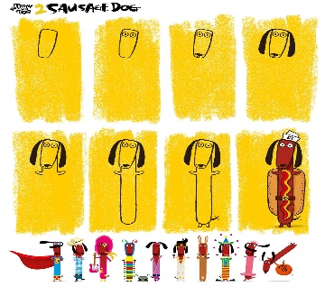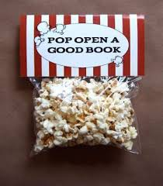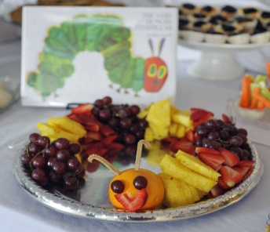 | Art/D&T  Draw a sketch of your favourite character.  Design a new front cover for your favourite book.  Design a bedroom for your character based on their personality – you could put this in a shoe box. Think about what is on the walls, the colour scheme, the furniture etc.  Design a new outfit for your book character to wear.
Additional Writing opportunities  Write a letter to your favourite author telling them what you like the most about their books or what is your favourite book.  Turn part of a story into a comic strip. |  | Computing  Write a blog for one of the characters based on something that has happened to them in a story.  Visit your favourite author’s website.  Read a book on Bug Club and complete the quiz.

