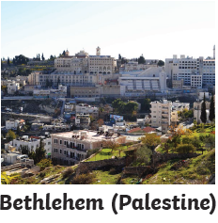  Birthplace of Jesus. | 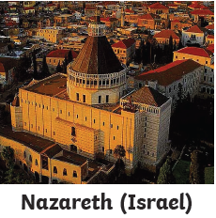  Place where Jesus lived with Mary and Joseph. | 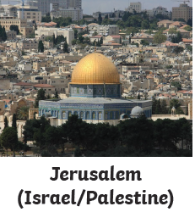  The place where Jesus died.
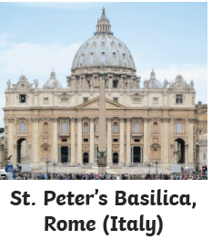  Where St Peter (a disciple of Christ and 1st Bishop of Rome) is said to be buried. It is the home of the Pope. | 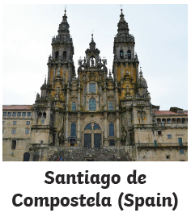  One of Jesus’ disciples (St James) is said to be buried here. | 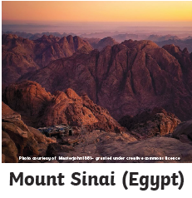  This is where Moses received the 10 Commandments (Old Testament)
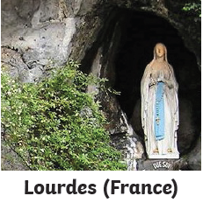  A site where saw a vision of Mary, Jesus’ mother. A spring was found and pilgrims believe it can cure them. | 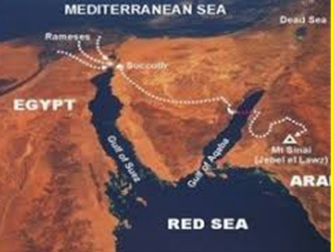  The Red Sea  The place where Moses escorted the children of Israel to safety away from the Egyptians. | 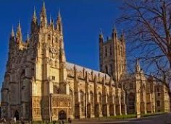  Canterbury Cathedral  Archbishop Thomas A Beckett was murdered here and made a saint after his death in 1170.

