Year 1 Home Learning W/C 25/1/21
Our focus will be: ‘air’ and ‘ure’
air
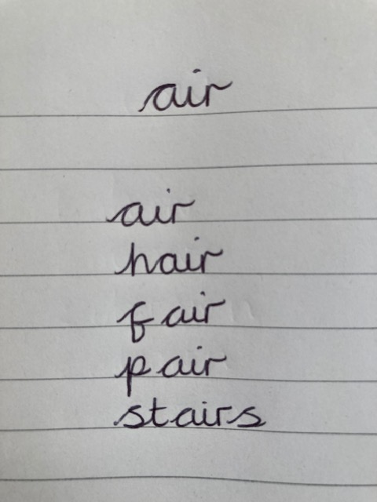
air
hair
fair
pair
stairs
ure
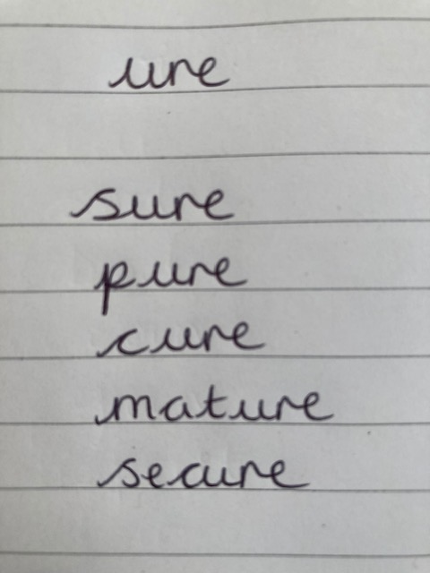
sure
pure
cure
mature
secure
Our SPaG focus is:
More work on revisiting adjectives and nouns – expanded noun phrases/describing things.
Combine with good sentence work.

Using all your practise at writing sentences (capital, full stop, spacing etc) and the ‘adjectives’ you wrote last week to describe your nouns, combine these to write a sentence about each object.

You may choose to use one adjective for each noun.
I ate a green apple. My mum is wearing her pink jumper.

Maybe you could include 2 nouns in each sentence.
I ate a green apple and a juicy pear. My mum wore her pink jumper and fluffy slippers.

Extension: If you use more than one adjective to describe your noun, you would use ‘commas in a list’.
I ate a crunchy, green apple and a soft, juicy pear.
My mum wore her pink, woolly jumper and her sparkly, fluffy slippers.

