LC: Can I calculate division with remainders?

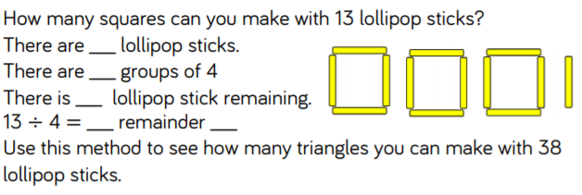
Draw the triangles to help you see how many groups you have.

Use grouping to solve the following calculations and identify any remainders.

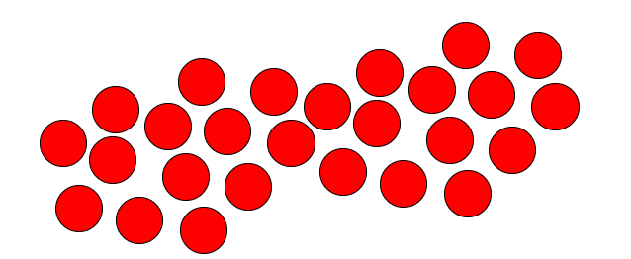
26 ÷ 5 = r
26 ÷ 8 = r

Now try some problem solving. If you have anything to hand like counters or dry pasta shapes, you could work this out practically!

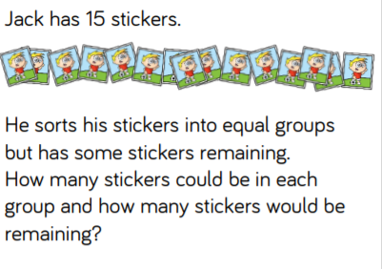

There are 23 sweets which have been shared into equal groups but there are always some left over. Can you show different combinations of equal groups and remainders which total 23?
Chilli challenge! Write down the division calculations with remainders for each of your examples.

