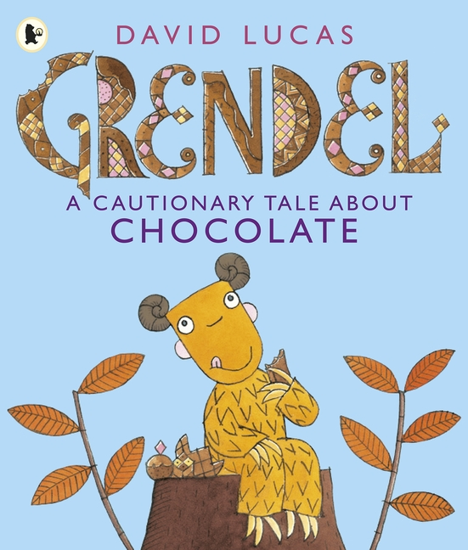

**LC: Can you make predictions about a book from the cover?**

* Basic sentence structure
* Conjunctions

**LC: Can you make predictions about a book from the cover?**

* Basic sentence structure
* Conjunctions

______________________________________________________________________________________________________________________________________________________________________________________________________________________________________________________________________________________________________________________________________________________________________________________________________________________________________________________________________________________________________________________________________________________________________________________________________________________________________________________________________________________________________________________________

**LC: Can you make predictions about a book from the cover?**

* Basic sentence structure
* Conjunctions

**LC: Can you make predictions about a book from the cover?**

* Basic sentence structure
* Conjunctions