

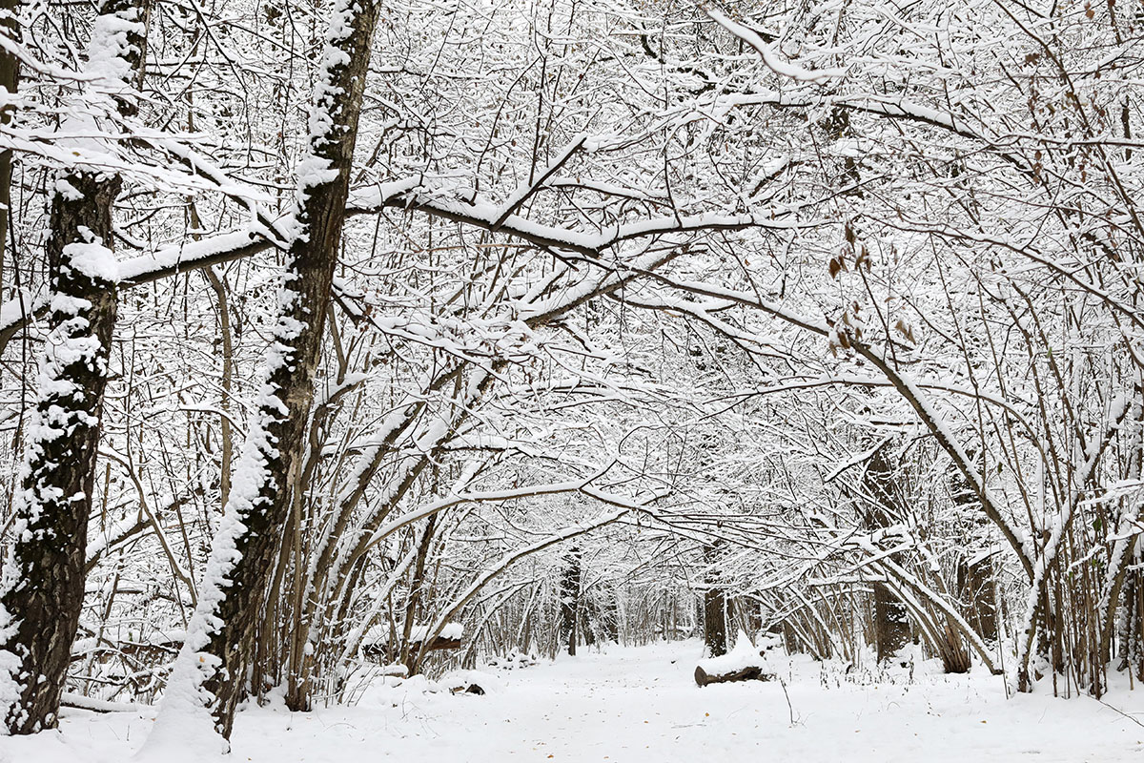

**LC. Can you write a line poem about winter?**

**SC** -adjectives - title

- verbs - lines

- adverbs - verses

- alliteration

- similes

________________________________________________________________________________________________________________________________________________________________________________________________________________________________________________________________________________________________________________________________________________________________________________________________________________________________________________________________________________________________________________________

________________________________________________________________________________________________________________________________________________________________________________________________________________________________________________________________________________________________________________________________________________________________________________________________________________________________________________________________________________________________________________________

 _________________________________________________________________________________________________________________________________________________________________________________________________________________________________________________________________________________________________________________________________________________________________________