Match the or words with their pictures:

|  |  |  |
| --- | --- | --- |
| http://cnx.org/content/m22603/latest/graphics3.png | http://www.clker.com/cliparts/e/d/c/7/12456951341992058408johnny_automatic_corn.svg.hi.png | http://3.bp.blogspot.com/_GbVUEzSS-54/TK3F8u7w6oI/AAAAAAAAFrc/PNV5O7Jt9rU/s1600/29913-Clipart-Illustration-Of-The-Sun-Rising-Over-Green-Grass-Casting-Rays-Of-Sunshine-In-The-Sky.jpg |
| _ _ _ _ _ | _ _ _ _ | _ _ _ _ _ _ _ |
| http://www.arthursclipart.org/music/music/orchestra%204.gif | http://www1.free-clipart.net/gallery2/clipart/Business/Cartoons/Paper_-_Torn.jpg | http://www.artvex.com/content/Clip_Art/Foods_and_Drinks/Fruits/Acorn/0014177.gif |
| _ _ _ _ _ _ _ _ _ | _ _ _ _ | _ _ _ _ _ |
| http://school.discoveryeducation.com/clipart/images/frnchorn.gif | http://www.free-clipart-pictures.net/free_clipart/horse_clipart/arabian_horse_clipart.gif | http://images.clipartof.com/thumbnails/1056437-Royalty-Free-Vector-Clip-Art-Illustration-Of-An-Evil-Lightning-Storm-Cloud.jpg |
| _ _ _ _ | _ _ _ _ _ | _ _ _ _ _ |

Storm corn acorn orchestra horse morning short torn horn

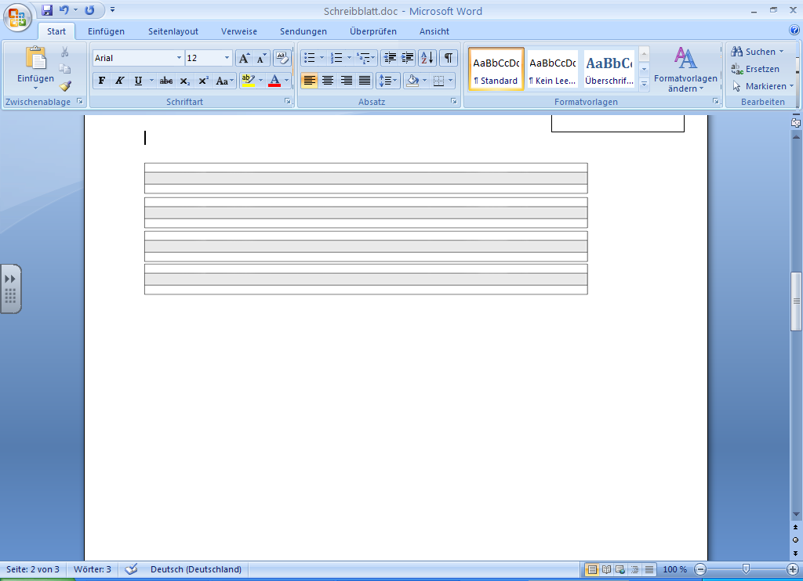

OR Word Search

|  |  |  |  |
| --- | --- | --- | --- |
| Write the words from the word bank under the correct pictures and then find them in the grid below.  **Word Bank** | | | |
| acorn | corn | fork | fort |
| horn | horse | port | storm |
|  | | | |
| corn | storm | acorn | horse |
| fork | port | horn | fort |
| ORsearch | | | |