Year 2 Challenges Faces on 3D Shapes

A face is a flat or curved surface on a 3D shape. For example, a cube has six faces, a cylinder has three and a sphere has just one.

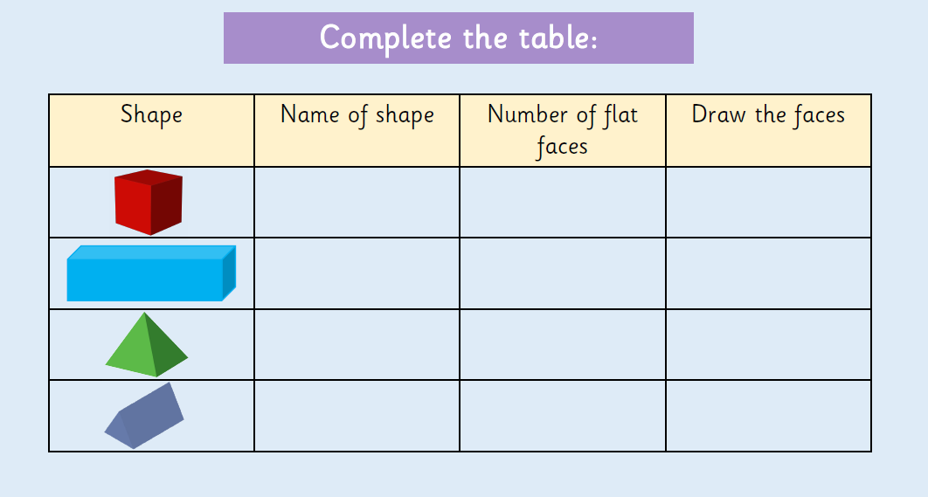

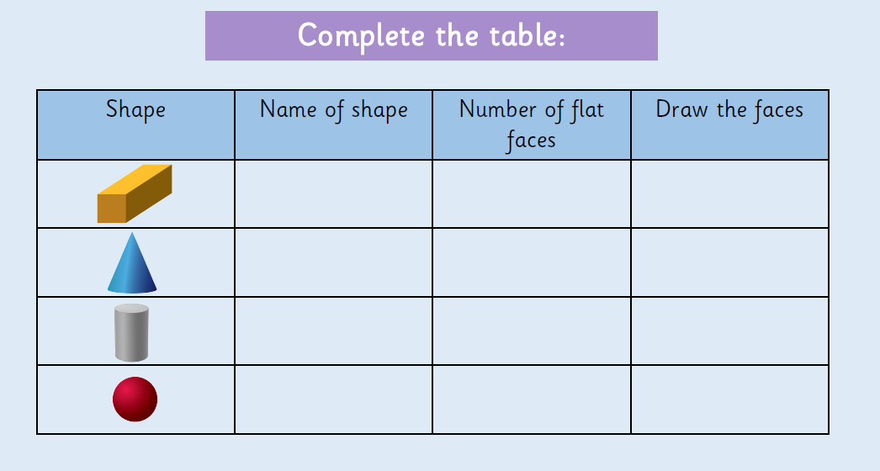

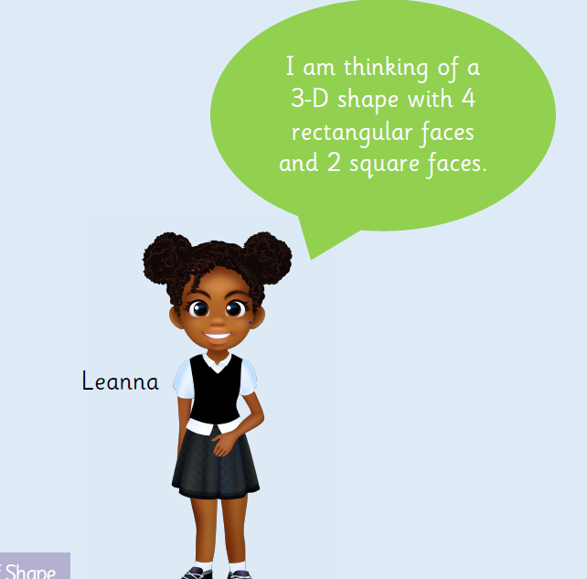
What is Leanna’s shape?

