When an animal or plant dies its remains usually rot away to nothing. Sometimes though, when the conditions are just right and its remains can be buried quickly, it may be fossilised. There are several different ways fossils are formed. Here we go through the five steps of fossilisation to make a typical 'mould and cast' fossil.

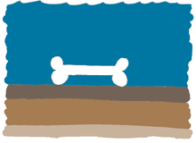
An animal dies, its skeleton settles on the sea floor and is buried by sediment.
An animal dies and its body sinks to the sea floor. The soft parts of the animal rot away, leaving only its skeleton. The skeleton is buried by sediment (like mud or sand) falling from the ocean above. The sea floor is an ideal place for fossilisation, which explains why many fossils are marine (from animals that lived in the sea). Land animals may die and be swept out to sea to be buried in the same way.

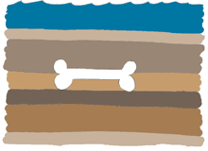
The sediment surrounding the skeleton thickens and begins to turn to stone.
The skeleton continues to be buried as sediment is added to the surface of the sea floor. As the sea floor sinks, pressure increases in the lower layers of sediment and it turns it into hard rock.

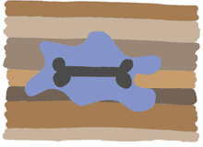
The skeleton dissolves and a mould is formed.
Now buried at depth and surrounded by stone, the skeleton is dissolved by ground water. This leaves a cavity (or hole) preserving the shape of the original skeleton. This cavity is known as a natural mould.

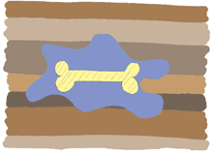
Minerals crystallise inside the mould and a cast is formed.
Water rich in minerals enters the mould, and fills the cavity. The minerals deposited in the mould form a cast of the mould. This cast has the same shape as the original skeleton, but none of its internal features.

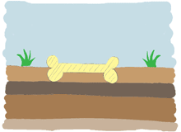
The fossil is exposed on the Earth's surface.
Millions of years later, the rock surrounding the skeleton rises to the Earth's surface (this happens during mountain building, earthquakes and other earth processes). The rock is worn away by wind and rain, and the fossil is now exposed, waiting to be found!

