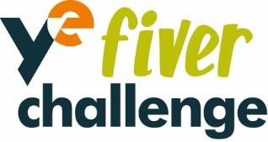

22nd May 2023

Dear Parents and Carers

Today I have been in school, talking to Year 6 about the BPS Summer Festival 2023. As you may be aware, last year the Year 6 children planned and managed very successful stalls at the Summer Festival, with collective Sales exceeding £1000! It was great to see Y6 children so keen to give something back to the school and act as role models for our younger children.
This year, we are encouraging Year 6 to participate again and linking the opportunity with the month long Fiver Challenge. www.fiverchallenge.org.uk The Fiver challenge is a free national competition for young people aged 5 – 11 years. It is run by Young Enterprise, the UK’s leading enterprise and financial education charity, which helps bring learning to life and encourage future aspirations in young people.

BPS Summer Festival will take place on Sunday 25th June. Pupils who participate will be given £5 each and have four weeks to research, create, plan and run their own mini business. Children have been asked to work as a team if they can, with a maximum of four children in each team. The £5 pledge will be provided by Bramhope Primary PTA, and the profit will be included in the Summer Festival 2023 fundraising.

As part of the Fiver Challenge, there will be an opportunity for teams to enter competitions. This includes the best logo design, best sales pitch as well as the National Competition, where teams could win great prizes and be featured in the Fiver Showcase.

The Y6 children are all excited about their challenge and any help and encouragement you can offer them would really be appreciated. Giving our children the opportunity to create, plan and run their own mini business is a great way to gain core enterprise skills such as communication, confidence and creativity. We also hope children will have lots of fun along the way too!

Thank you for your support,

Fiona

PTA Treasurer

