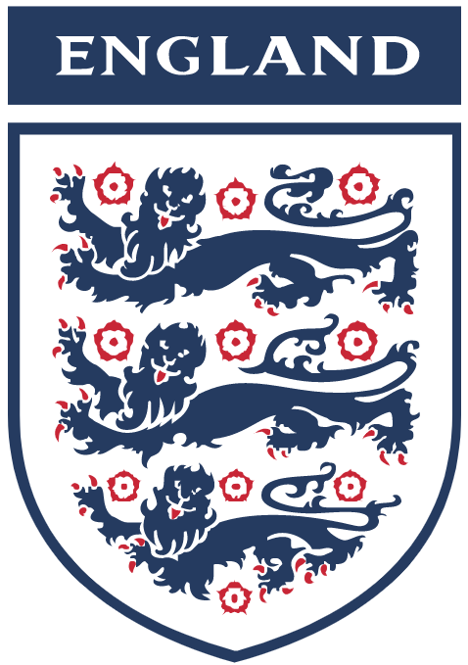
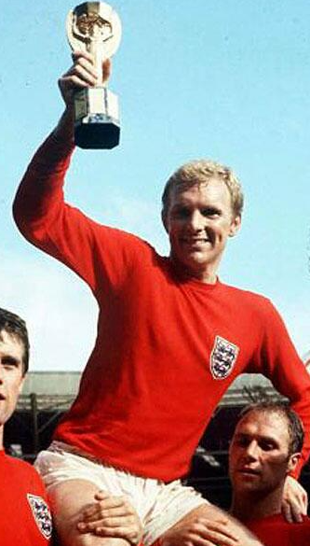
Three Lions
The three lions of the badge of the England Football Association.
It's coming home
It's coming home
It's coming
Football's coming home
(repeat)
England Captain Bobby Moore with the Jules Rimet trophy in 1966.
Everyone seems to know the score
They've seen it all before
They just know
They're so sure
Writers of the song.
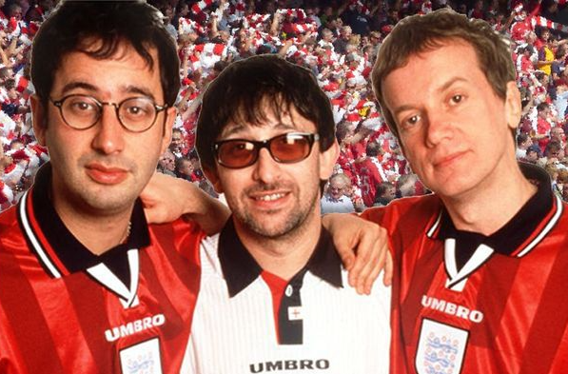
David Baddiel  A comedian and now a writer of children’s books. | Ian Broudie  Lead singer of The Lightning Seeds, Ian wrote the music for the song. | Frank Skinner  A famous comedian, Frank is now a presenter on radio and TV.
That England's gonna throw it away
Gonna blow it away
But I know they can play
'Cause I remember
Three Lions on a shirt
Jules Rimet still gleaming
Thirty years of hurt
Never stopped me dreaming
So many jokes, so many sneers
But all those oh-so-nears
Wear you down
Through the years
But I still see that tackle by Moore
And when Lineker scored
Bobby belting the ball
And Nobby dancing…

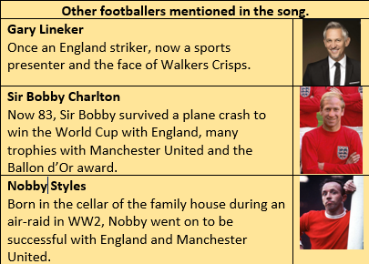
What is the story behind the song? The rules of modern football and the first professional football association were created in England in the 1800s. This is why England football fans consider success for their national team as football ‘coming home’. The song was written in 1996, 30 years after England won the football world cup – then called the Jules Rimet trophy.
Questions:
- Why is the song called ‘Three Lions’?
- Who wrote the music to the song?
- Who was the captain of England in 1966?
- Why are there ’30 years of hurt’?
- What makes the writer of the song hopeful that England can win?
- Why do England football fans consider winning as ‘football coming home’?
Challenge
Can you write an extra verse for the song?

