Year 2 Maths worksheet.
LC: Can you add three 1-digit numbers?

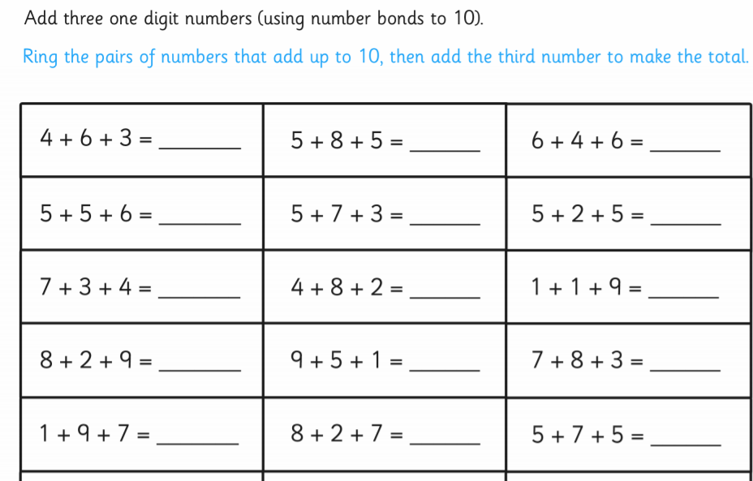
LC:


