LC Can you write a short paragraph to explain:
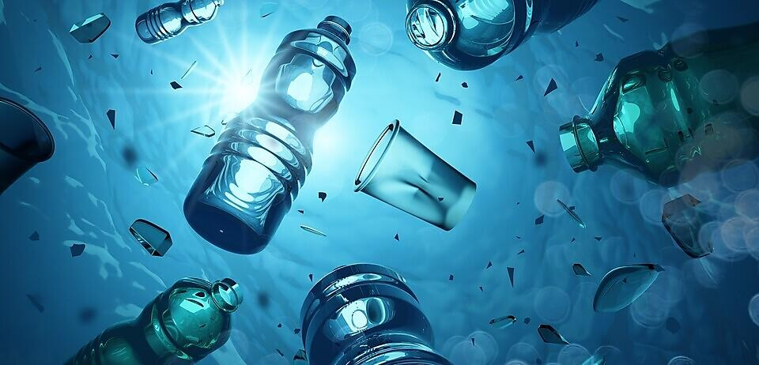
- What is plastic pollution is and how can it harm ocean life?
- What are some of the main causes of plastic pollution?

LC Can you write a short paragraph to explain:
- What is plastic pollution is and how can it harm ocean life?
- What are some of the main causes of plastic pollution?

