LC Can you write a non-chronological report? (about whales)?
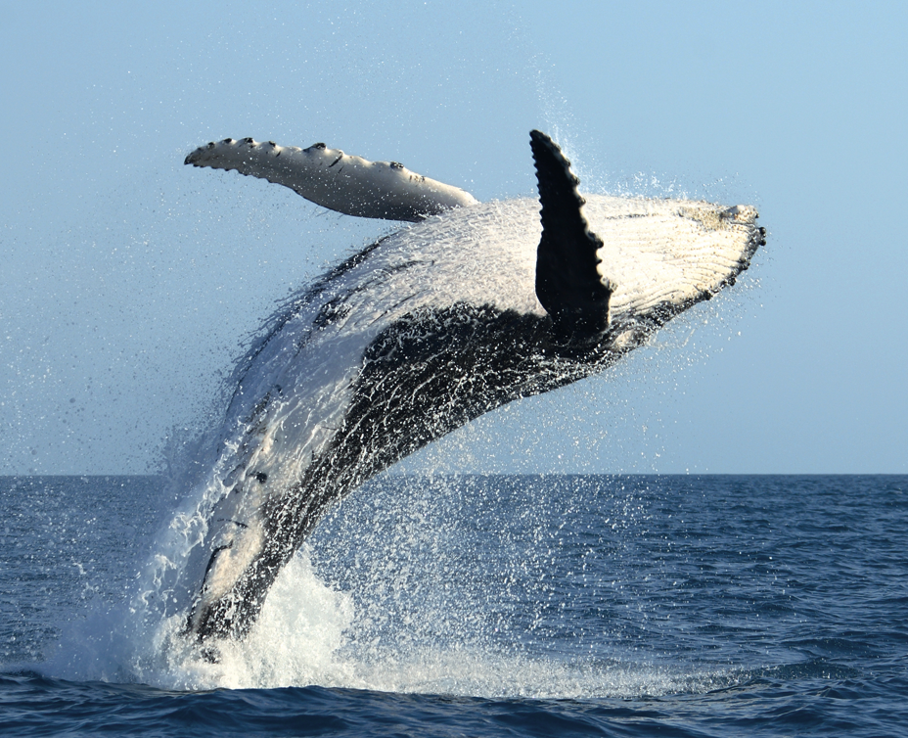
SC - statement sentences (clear, key facts about a whale)
- ToolKit (especially focus on capital letters, full stops and conjunctions)
- Subheadings (with key information sorted into categories)
- An introduction and a conclusion paragraph.


