LC Can you write a non-fiction report? (about whales)
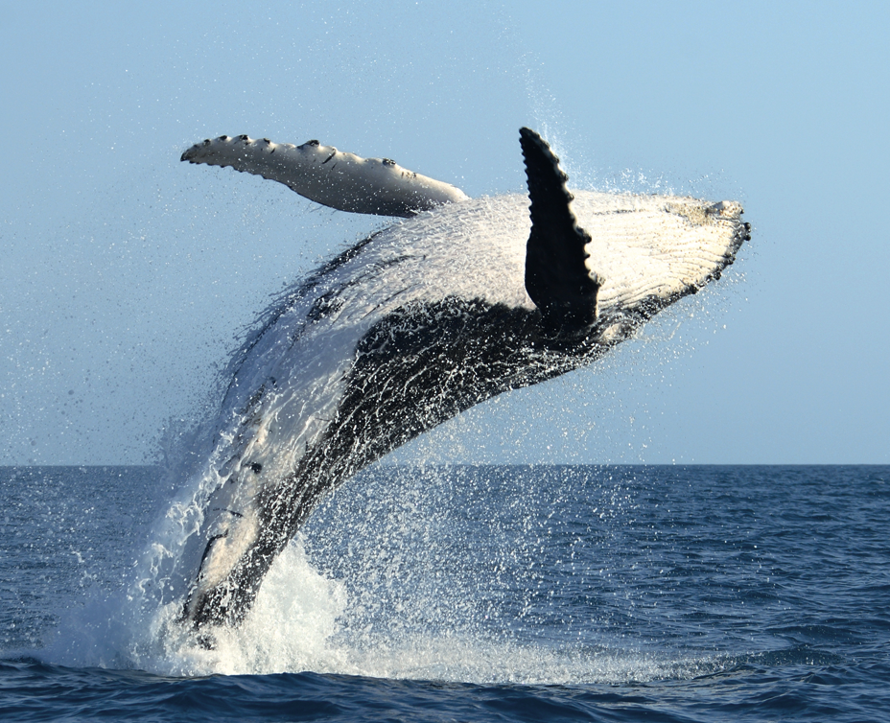
SC - Statement sentences (clear, key facts about a whale)
- ToolKit (especially focus on capital letters, full stops and conjunctions)


