Extra Maths activities for learning on Length, Height and Distance
- Go on a walk around your local area. Compare the different height of trees and talk about which are shortest and tallest. Collect some twigs; can you put them in order from shortest to tallest?

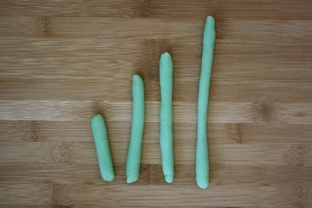
- Use playdough to measure different lengths. Roll the playdough into snakes and compare the lengths of them. Which are the longest? How could you make them longer? Which are the shortest? Can you use bricks to measure them? How many bricks different are the longest and shortest snakes?

- Push toy cars and see how far they go. Which one went the furthest? How could you make them go further? Try again and this time measure how far they went in footsteps. Can your family push them further than you?

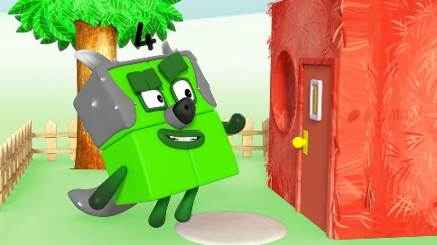
- Watch Numberblocks The Three Little Pigs https://www.bbc.co.uk/iplayer/episode/b08cqtk0/numberblocks-series-1-three-little-pigs. Discuss which house was the tallest? How many bricks tall was it? Which was the shortest? Was Four’s house taller as it had 4 bricks on it?

- Mark your height on a wall with a pencil or a sticker. How tall are you compared to the people in your family? Over time, how quickly are you growing?

- Draw and cut around your hands. Now do the same with your adults hands. Which hands are wider/narrower? How do you know? Can you use the words wider and narrower correctly?

