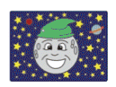 |   igh | 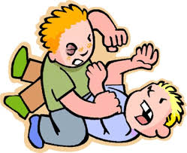
_ igh__ | l __ __ __ t | f __ __ __ t
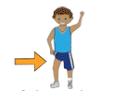 | 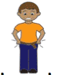 | 
th __ __ __ | t __ __ __ t | l __ __ __ t
 |  | 
kn __ __ __ t | h __ __ __ | r __ __ __ t
 | 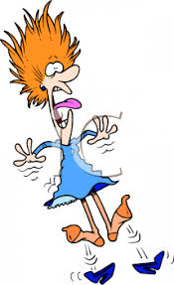 | 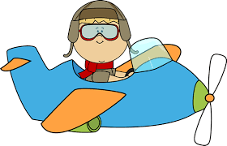
l __ __ __ tning | f __ __ __ __ | f__ __ __ __
Can you complete the words?

