Chilli Challenge

Can you show your understanding of tenths?

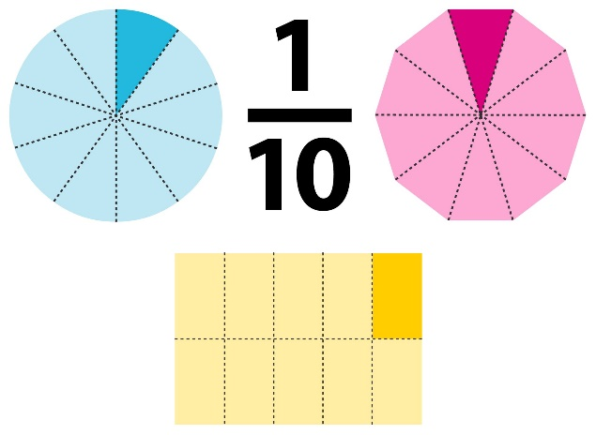
You could:
- Draw shapes split into tenths
- Use lego to show tenths
- Show tenths using a set of objects
- Find a tenth of an amount e.g. what is one tenth of 20? 50?


