LC Can you write a character description?

(Of a character in Charlie and the Chocolate Factory or the 6th lucky winner)

Success Criteria:
-Adjectives (personality and appearance)
-Commas in a list (between a list of describing adjectives)
- Similes (to support your description)
- Verbs & adverbs (if these help to describe actions of your character)

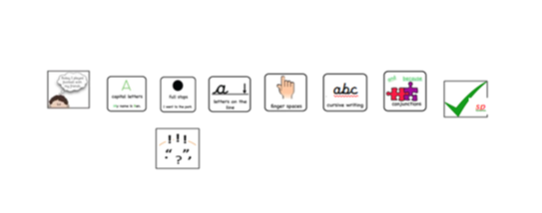
Writer’s ToolKit:

