Year 2 Challenges 2D & 3D Shapes

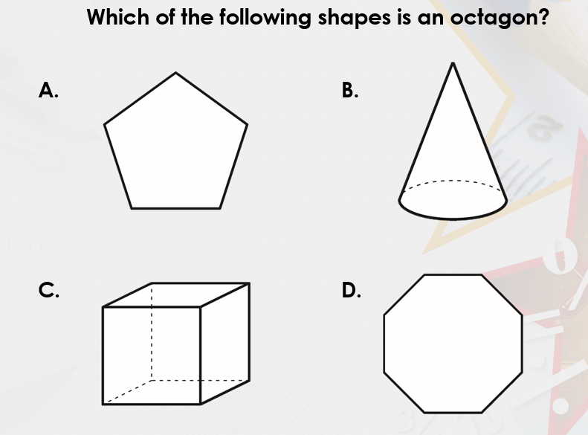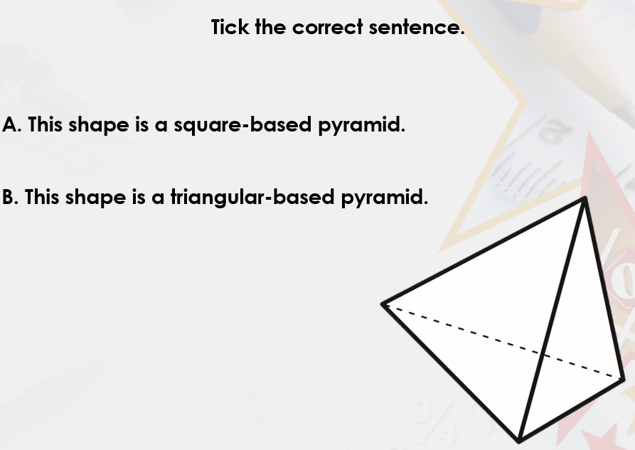

Complete the statements.
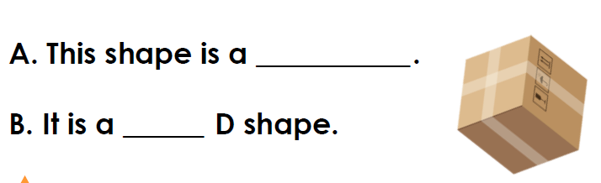

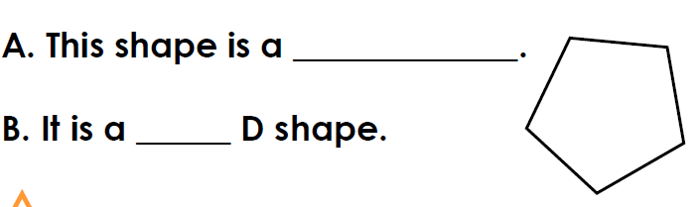

Go on a Shape Hunt around your home. Create a tally chart to record which shapes you find.

