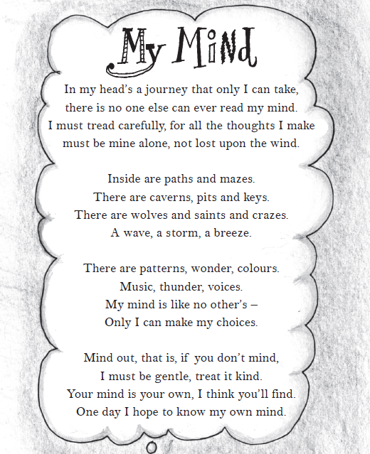
My Mind by Ros Asquith
Retrieving Information
- What word does the poet use as a synonym for ‘hole’?
- How does the poet say she must behave towards her mind?
- The poet uses the word ‘mind’ in different ways so that it has different meanings. Give two examples from the poem.
Making Inferences
- Do you think the poet is a young person or an older person? Explain why using evidence from the text.
- Why do you think the poet wants their thoughts to “be mine alone”?
Writer’s choices
- Why do you think the writer compares her mind to “paths and mazes”?
- Why has the poet chosen to talk about “wolves” in her mind?
Challenge question
Do you think the poet’s mind is a happy, sad or angry place? Support your answer with examples from the text.

