LC: Can I divide 2 digits by 1 digit?
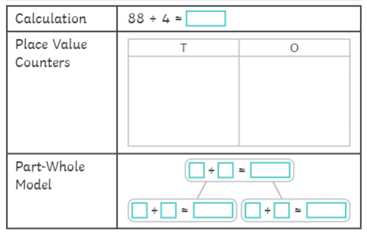
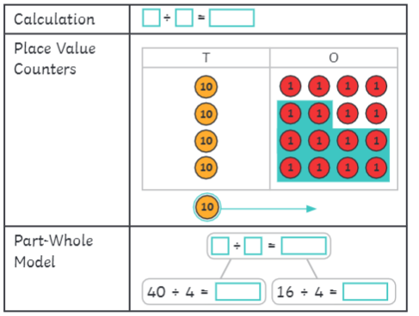
Use a part whole model or a tens and ones grid to answer the following:
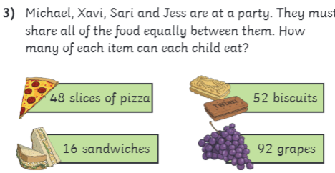

Now let’s practice…
Solve the following calculations using either tens and ones grid, partitioning or times tables:
64 ÷ 4 =
42 ÷ 3 =
36 ÷ 3 =
51 ÷ 3 =
96 ÷ 8 =

Chilli Challenge


