Year 1 Home Learning W/C 11/1/21
Our focus will be: ‘ur’ and ‘ear’
Don’t forget, as you learn your spellings it is also a really good opportunity to practise your cursive letter formations. It is also a good idea to have a go at learning how to join the digraph and trigraph accurately.
ur
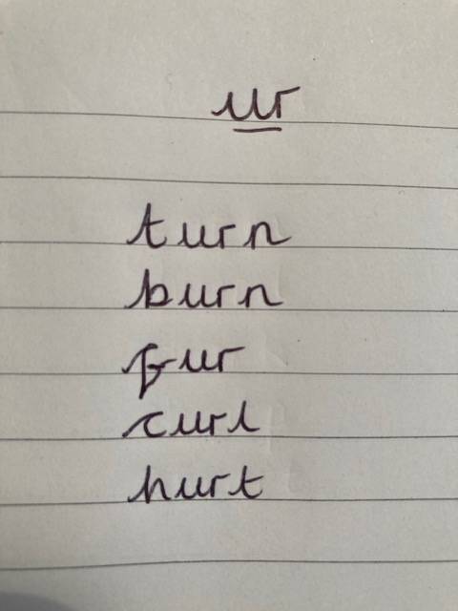
turn
burn
fur
curl
hurt
ear
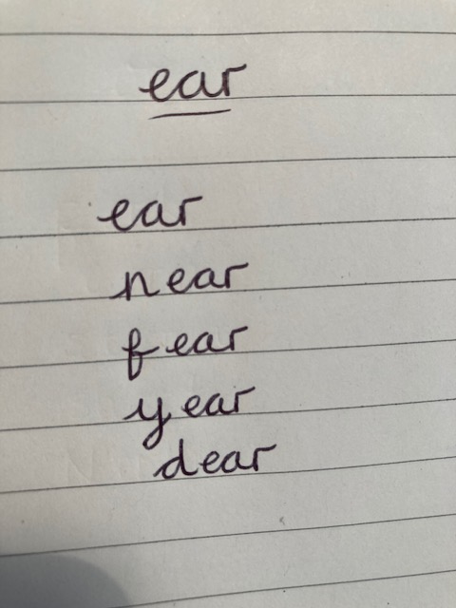
ear
near
fear
year
dear
Our SPaG focus is:
Continue to recap the basics in sentence writing, this week with question sentences and question marks:
- Start with a capital letter.
- End with a question mark.
- Appropriate spacing - not too big between letters within each word and a finger space (or equivalent to fitting one of your letter ‘o’ in) between words.
- Appropriate sized letters including lots of cursive formations.
Can you write some sentences using this week’s spellings.
You may find these question words helpful: Who What When Where How Why Did Do If Can.

