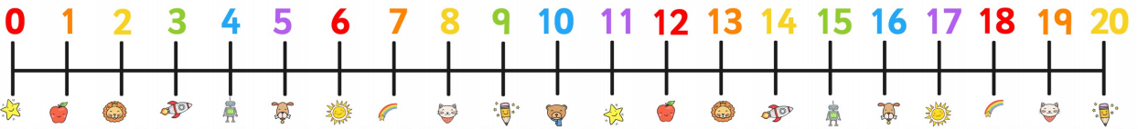
15 – 6 =

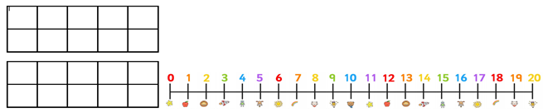
17 – 9 =
12 – 4 =

14 – 6 =

11 – 5 =

