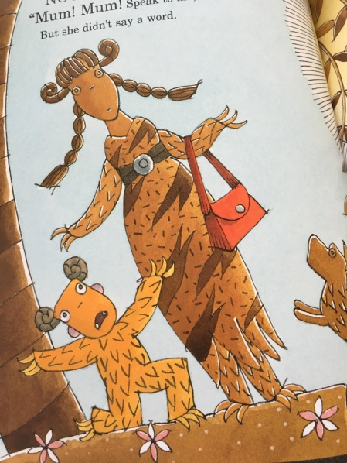
LC Can you retell the key events of the story of Grendel?
Sc – sequence the story
- time adverbials
- feelings
- conjunctions
- Writer’s Toolkit

