Tuesday 5th January 2021
LC: Can you recognise equal groups and show the repeated additions?
SC: Write the stem sentence
Write the repeated addition equation.



__________________________________________________________________________________

+ + =



_________________________________________________________________________________

++ + =



+ + =

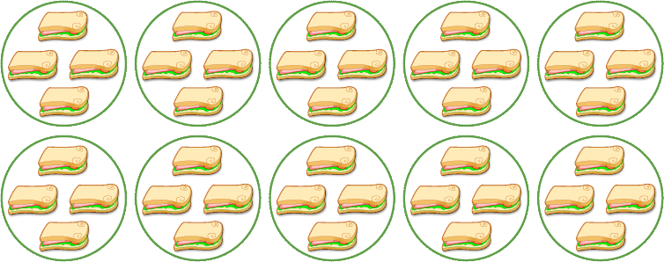

+ + + + + + +

+ =

Can you draw a picture to show 4 equal groups of 3?
Write the stem sentence.
Write the repeated addition equation.

