Orienteering at Home!
Creating your map
All you need is a blank piece of paper. Then using a pencil and ruler, just sketch out your garden, a room or your whole house. You could create a map for someone else to try out or maybe someone might create one for you to try!
You can download these markers to use around your home from our class files or just make your own! You could use toys as your markers to find around your home.
Example map:
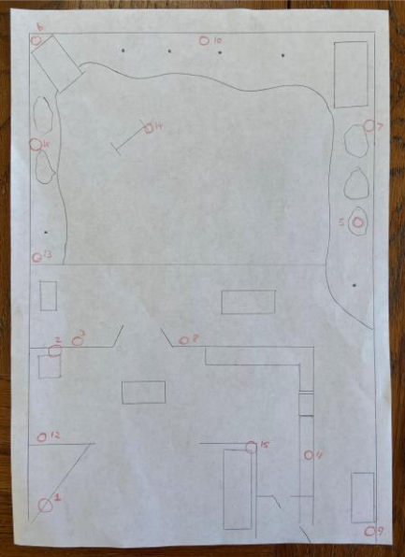
This example shows 15 different markers around the house and garden (the red circles). You may want to start with less. You need to find all the markers on your map.
You could put a letter on the bottom of each marker to spell out a word (make sure you go to each marker in the correct order).
To make it trickier, you could place more markers down so that you have to be careful to find the correct ones.
Mark a triangle on the map as your start point and use this start point to help you keep your map orientated correctly. Before you set off, try to identify areas of your home or garden that you recognise on your map to help you get your bearings. Enjoy!

