Bramhope Primary School
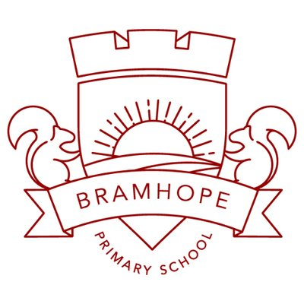

English- Reading Road Map

Year 1
1. Word reading- decoding
- apply phonic knowledge to decode words
- speedily read all 40+ letters/groups for 40+ phonemes
- read accurately by blending taught GPC
- read common exception words
- read common suffixes (-s, -es, -ing, -ed, etc.)
- read multi-syllable words containing taught GPCs
- read contractions and understanding use of apostrophe e.g. I’m, we’ll
- read aloud phonically-decodable texts.

2. Reading experience – range of reading, familiarity with texts and poetry and performance
- listening to and discussing a wide range of poems, stories and non-fiction at a level beyond that at which they can read independently
- being encouraged to link what they read or hear read to their own experiences
- becoming very familiar with key stories, fairy stories and traditional tales, retelling them and considering their particular characteristics
- recognising and joining in with predictable phrases
- learning to appreciate rhymes and poems, and to recite some by heart.
- accurately read texts that are consistent with their developing phonic knowledge, that do not require them to use other strategies to work out words.
- re-read texts to build up fluency and confidence in word reading.

3. Comprehension - word meanings, understanding, inference, prediction, authorial intent, non-fiction and discussing reading
- discussing word meanings, linking new meanings to those already known
- drawing on what they already know or on background information and vocabulary provided by the teacher
- checking that the text makes sense to them as they read and correcting inaccurate reading
- discussing the significance of the title and events
- making inferences on the basis of what is being said and done
- predicting what might happen on the basis of what has been read so far
- participate in discussion about what is read to them, taking turns and listening to what others say
- explain clearly their understanding of what is read to them.

