Term | Month | Reception | Year 1 | Year 2 | Year 3/4 | Year 5/6 | Other
Au 1 | September |  | Elicit knowledge of trees, flowers, bushes, weeds, basic structure of plants.  Identify tree (to revisit throughout the year to note changes.) |  | Plant part scavenging – (making observations about parts of plants).
 | October |  | Autumn seasonal observations – (changing leaves (leaf hunt) - multiple visits to wildlife garden as trees change week by week). | Seed collecting – (classify seeds collected.)  Crocus bulb planting.  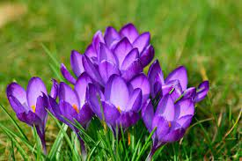 | Seed collecting – (save for seed dispersal).
Au 2 | November |  |  |  | Plant daffodil bulbs (to use in investigations in Spring).  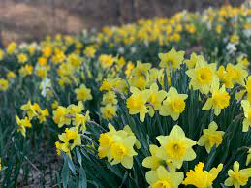 | Plant hyacinth bulbs (to make observations later in year about parent plants.)  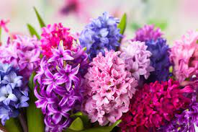
 | December
Spr 1 | January |  | Winter seasonal observations – (evergreen and deciduous comparisons). |  | Plant part scavenging in wild life garden (identifying main parts of plants).  Observe daffodil bulbs - (Investigating conditions for mature plants)  Range of indoor plants to observe – (cactus, bulbs, house plants.) |  | Plan vegetable beds. Order seeds.
 | February |  | Observe early signs of spring e.g. bulbs  Bird feeders out/make (observing common birds). |  | Investigating transportation of water in plants (celery investigation). | Chitting potatoes (growing from parent plants – tubers)  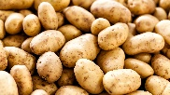  Propagating spider plants (growing plants from cuttings). | Clean out/put up nest boxes.
Spr 2 | March |  | Spring seasonal observations – flowering bulbs/blossom/new leaves | Observe spring bulbs planted. | Sow courgette and sweet peas seeds indoors. (Observe stages of flowering plant lifecycle).  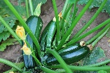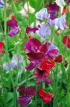  Collect flowering spring bulbs – identify key parts. | Observe hyacinth bulbs | Check for frog spawn.
 | April | Plant broad bean seeds outdoors.  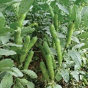 | Sow runner/dwarf bean seeds indoors –(identifying basic structure of plant).  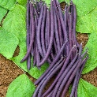 |  | Observe spring flowering plants and identifying plants in wildlife garden | Sow tomatoes and nasturtium seeds indoors.  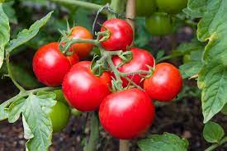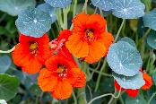  Planting out potatoes in bags. | Prepare vegetable beds, weeding, turning over soil, adding fresh compost.
Su 1 | May |  | Plant out runner bean/dwarf bean plants.  Plan/design wildflower bed and then plant seeds.  Plant up pots of summer bedding flowers (Identify common flowers) | Sow sunflower seeds indoors – (investigate different growing conditions for seeds – sunflower diary weekly.)  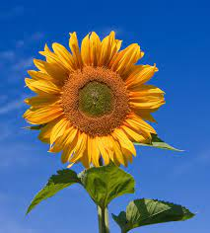 | Plant out sweet peas and courgette plants. |  | Maintain and weed veg patches (each class responsible for own). Rota for classes to water garden.
 | June | Harvest broad beans. |  | Planting lettuce seeds/radishes outdoors  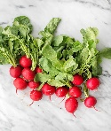  Take home sunflower seeds to be planted in gardens or plant in our garden. | Identify flowering plants  Observe pollinators in the garden | Plant out tomatoes and nasturtiums. | Pollinators in garden to observe.
Su 2 | July |  | Summer seasonal observations – (identifying flowering plants and wildlife using spotter sheets.)  Visit wildflower bed – make observations  Harvest runner/dwarf beans. | Harvest lettuce and radishes.  Identify summer flowering plants. | Harvest courgettes. | Harvest potatoes and tomatoes. | Pollinators in garden.  Harvest crops.
 | August

