Bramhope Primary School
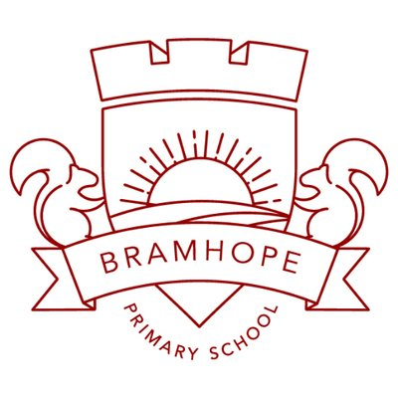

English- Writing Road Map

Reception
30-50 mth 40-60mth

ELG:
Children use their phonics knowledge to write words in ways which match their spoken sounds. They also write some irregular common words. They write simple sentences which can be read by themselves and others. Some words are spelt correctly and others are phonetically plausible.

Exceeding statement:
Children can spell phonically regular words of more than 1 syllable as well as many irregular but high frequency words. They use key features of narrative in their own writing.

1.Spelling:

- To continue a rhyming string.
- To hear and say the initial sound in words.
- To segment the sounds in simple words and blend them together.
- To link sounds to letters, naming and sounding the letters of the alphabet.

- To use their phonic knowledge to write words in ways which match their spoken sounds.
- To write some irregular common words.
- Use phonic knowledge to write simple regular words e.g. sat, pin, fish, chip.
- Make phonetically plausible attempts to wrote more complex words using phase 3 phonics e.g. sheep, quick, fight

- Children can spell phonically regular words of more than 1 syllable as well as many irregular but high frequency words.

2. Handwriting and Presentation:

- To draw lines and circles using gross motor movements.
- To use one-handed tools and equipment, e.g. makes snips in paper with child scissors.
- To hold a pencil between thumb and two fingers, no longer using whole-hand grasp.
- To hold a pencil near point between first two fingers and thumb, and use it with good control.
- To copy some letters, e.g. letters from their name.
- To sometimes give meaning to marks as they draw and paint.
- To realise tools can be used for a purpose.

- To show a preference for a dominant hand.
- To begin to use anticlockwise movement and retrace vertical lines.
- To begin to form recognisable letters.
- To use a pencil and hold it effectively to form recognisable letters, most of which are correctly formed.
- To give meaning to marks they make as they draw, write and paint.
- To use some clearly identifiable letters to communicate meaning, representing some sounds correctly and in sequence.

- Can use a pencil effectively using the correct pencil grip
- Can correctly form recognisable letters using the cursive script and correct starting position
- Letters sit on the line

- Letters are of a consistent size, in cursive script, sitting on the line with appropriate spacing.

3. Composition:

- To speak to retell a simple past event in correct order. For example, ‘I went down slide’.
- To use talk to connect ideas, explain what is happening and anticipate what might happen next, recall and relive past experiences.
- To use talk in pretending that objects stand for something else in play. For example, ‘this box is my castle’.
- To engage in imaginative role play based on own first-hand experiences.
- To build stories around toys, e.g. farm animals needing rescue from an armchair ‘cliff’.
- To capture experiences and responses with a range of media, such as music, dance and paint and other materials or words.

- To link statements and stick to a main theme or intention.
- To use talk to organise, sequence and clarify thinking, ideas, feelings and events.
- To introduce a storyline or narrative into their play.
- To play cooperatively as part of a group to develop and act out a narrative.

- To develop their own narratives and explanations by connecting ideas or events.
- To express themselves effectively, showing awareness of listeners’ needs.
- To write own name (forming all letters correctly)
- Can write labels and captions using phonics e.g. label the parts of a plant or car.
- To attempt to write short sentences in meaningful contexts.
- To write simple sentences which can be read by themselves and others. Some words are spelt correctly and others are phonetically plausible.
- Attempt writing for different purposes using features of different forms e.g. lists, stories, instructions.
- Can show an understanding of the elements of stories in my writing e.g characters, sequence of events, openings, endings, settings, problems and solutions.

- Use key features of narrative in their own writing.
- Produce a string of sentences / completed story which they can read back and can be read (phonetically plausible) by others

4. Vocabulary, grammar and punctuation:

letter, capital letter, word, finger space, sentence, punctuation, full stop

- To use vocabulary focused on objects and people that are of particular importance to them.
- To build up vocabulary that reflects the breadth of their experiences.
- To begin to understand ‘why’ and ‘how’ questions.
- To question why things happen and give explanations and ask questions, e.g. who, what, when, how.
- To use a range of tenses in speech. For example, play, playing, will play, played.
- To begin to use more complex sentences to link thoughts when speaking, e.g. using ‘and’ and ‘because’.
- To show an understanding of prepositions, such as ‘under’, ‘on top’, ‘behind’ by carrying out an action or selecting correct picture.

- To extend vocabulary, especially by grouping and naming, exploring the meaning and sounds of new words.
- To use language to imagine and recreate roles and experiences in play situations.

- To answer ‘how’ and ‘why’ questions about their experiences and in response to stories or events.
- To use past, present and future forms accurately when talking about events that have happened or are to happen in the future.
- Can begin to form simple sentences using a capital letter, finger (appropriate/relative) spaces and full stop.

