The Bramhope Show
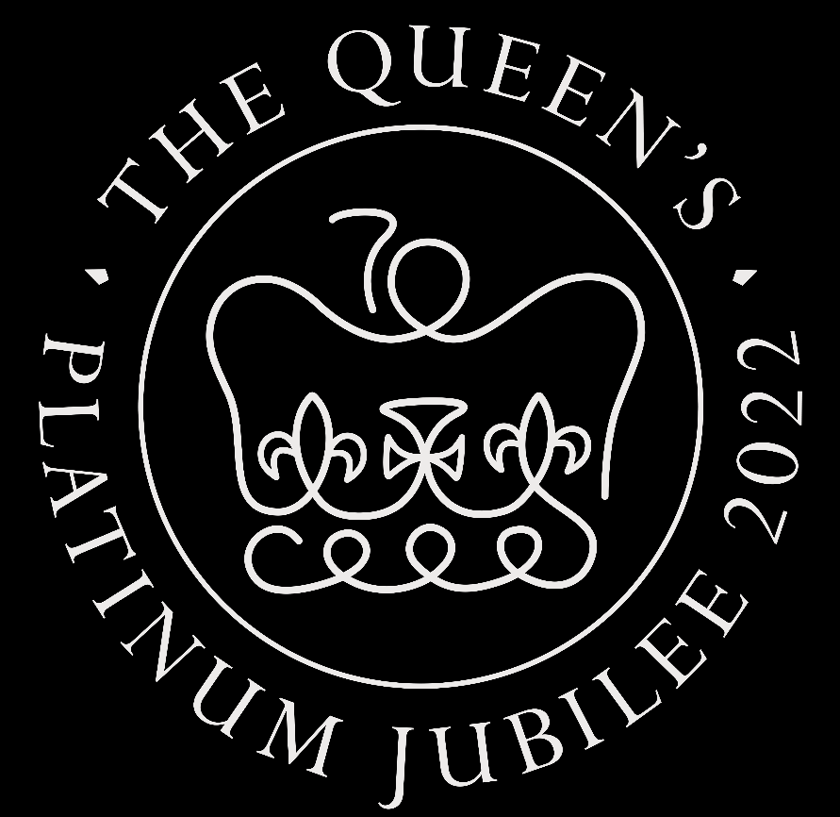
Sunday 11th September 2022
1pm – 4pm

Admission: Adults £3.00 Under 16s & Senior Citizens £1.00

Designed by………………………………… Age………………

The Bramhope Show is looking for a fresh new design for the front cover of the show programme!

Enter this exciting competition and see your name in print!

Theme for 2022 is The Queen’s Jubilee!

Competition: Open to all BPS pupils & Bramhope Residents.

Please return to the school office or Lily’s of Bramhope by Friday 20th May 2022.

Tips: You could include BBQ & bar, Stalls & Sideshows, Children’s Entertainer, Pet Show, Tea Room in your design!

Winner will be chosen by the Bramhope Show committee members and a prize will be given.

Good luck!

